(Approx. 1411 words)

How Do I Love Thee – Let Me Count the Wyze
By Greg Skalka, President
Under the Computer Hood User Group
https://uchug.org/
president ** uchug.org

I grew up waking early each day. I never developed a habit of sleeping in, but I almost always got up at the same time each weekend or weekday. For nearly 40 years, I've been working full-time to support myself and my family, and I almost always have gone to work early in the day. For my present job, I wake before 4:30 AM and leave the house by 5:30 AM. This means that no matter the time of year, I'm getting ready for work and leaving before sunrise.
I'm very sensitive to light and sound when trying to sleep. To fall asleep and stay asleep, I must have darkness and quiet. I can sleep with uncorrelated sounds like white noise (I like having our Amazon Alexa play surf or thunderstorm sounds), but I can't sleep with a TV or radio on. On the other hand, my wife often falls asleep in the evening in her office chair at home with the lights on and the TV blaring. While I may imagine the flash of a nuclear bomb would not wake her, I try to be sensitive to my wife and keep sound and light from her as I get ready in the morning (she is almost always asleep when I leave).
My concern for her in this regard has always been an issue, as I have had a few near misses over the years for falls as I would stumble down the stairs in the dark. She wants the bedroom door left open for ventilation, so I can't turn on the lights over the stairs. I've tried carrying a small flashlight, but sometimes it would get misplaced, and I would be forced to descend without illumination. As I have gotten older, the risks to me from a fall have become greater.
Over the last few years, I have improved the situation by using smart home devices. For example, I programmed two Wemo smart lights to turn on each workday morning before I was scheduled to come out of the bedroom. One was in a bedroom at the far end of the hall, which provided just enough light to see the top part of the stairs. Another was in the living room at the bottom of the stairs. Both were far enough from the bedroom door that the bedroom stayed dark inside. In addition, the lights were programmed to turn off when I left for work, so little electricity was wasted.
This system worked pretty well but was not perfect. If my waking schedule varied a little, I could have the lights on unnecessarily or wait until the timer turned them on to go downstairs. In the winter, I would keep the far bedroom door closed to prevent having to heat it; if I forgot to open it when I went to bed, I'd wake to no light near the top of the stairs. Localized "path" lighting for the stairs would be optimal but challenging to install.
A few months ago, a visitor at one of our group's general meetings on Zoom told us about Wyze Night Lights (www.wyze.com). These small rechargeable stick-on lights use motion and light sensors to light your way at night. They can be linked so that one morning can trigger multiple ones (up to 10) to come on and light your path, and they go off after motion is no longer detected. They sounded like they would be perfect for my stairs.
I did not have time to try them, but our editor, who had a similar need, bought some and gave them high praise. So, after further discussions about them at our last meeting, I finally ordered a pack of three (model WLPNL) from Amazon ($26.99 at the time; they are $25.99 with Prime delivery today).
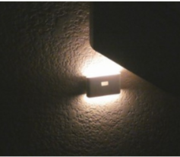
I was surprised by the small package when I received the shipment. Each light is only 3.25" x 2" x 3/8" thick. I charged all three before installing by connecting to the USB-C connector (charger and cable not included; fortunately, I had them) until the small status LED went out. A small slide switch on each side can be set to Off, On, and Auto (under motion detection control).
The most challenging part of using the Wyze lights was mounting them. Each light comes with a 1.25" square thin metal plate; the Wyze light contains a magnet that sticks it to the plate. Each also comes with an "easy pull tape," which should work like the Command strips for removable hooks. The installation recommendation for the lights is between 1.6 and 3.9 feet above the floor, probably for the best motion detection performance. So first, I selected locations on the outer wall of the stairway, with one at the top, one at the bottom, and one in the middle (where the stairs turned a corner). After that, I decided to go right to a permanent installation, putting them up with the easy pull tape. I initially had trouble getting the plastic covers from the easy pull film, but I could use it to mount the metal squares where I wanted them. However, when I put on the lights, they tended to rotate from level to around 45 degrees.
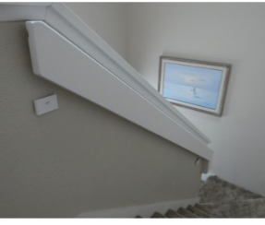
I called our editor, who suggested putting blue painter's tape over the metal plates. He had not used the easy stick tape; instead, he installed the plates with tape over them, so they could be easily relocated. I tried putting tape over my plates, and the additional friction did help keep the lights from being as prone to rotating. I set all three lights to Auto, and they all started blinking. After 30 seconds, the blinking stopped, and all the lights were linked. I tried them out after dark, and they worked well.
At this point, my wife saw my installation and did not like it. She thought the lights were too visible and unsightly. She said they would only be acceptable if they were moved to the opposite wall and just below the handrail, where they were partially hidden. That is when I found the easy stick tape was easy to stick but not easy to remove.
I tried pulling the removal tab as instructed, but the tab and tape snapped off, leaving about 1/3 of the tape remaining. This happened with all three lights. I used a thin metal ruler to pry the metal squares off the wall carefully.
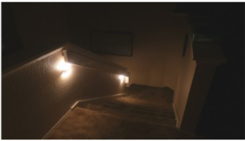
I successfully removed two without wall damage, but on the middle one, it pulled some of the paint off the wall (now I'm in trouble). The easy stick tape was still sticky enough to put the squares up in their new, authorized locations, though I put blue painter's tape over them for good measure. That's when I discovered why my lights had been rotating on the plates. It appears the metal plates were slightly convex (bulging out in the middle) when I first installed them, so there was only one contact point on the plate for the light to touch, allowing it to rotate around the point in the back where the magnet was located.
In my efforts to pry the plates off the wall from my first installation, I bent the plates so they were now more concave towards the light (the edges were bent out). This provided more contact points between the light and the plate and prevented the rotation I had seen previously.
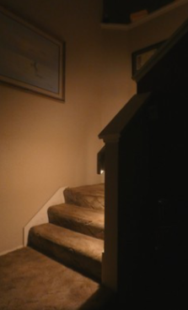
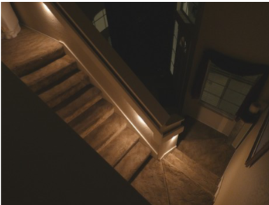
I have been using the Wyze lights in the mornings and evenings for a week, and they work great. They provide plenty of light, and the linking and motion detection features work well. However, in their present locations, slightly under the stair handrail, they may be more shaded from daylight and possibly run more time each day, thus using more battery power. I have yet to charge the lights again; their website indicates they could go for a month on a charge. Now I have disabled

the programming on some of my smart lights, as the Wyze lights provide all the light I need on demand. Now if I fall down the stairs, it will be my clumsy fault, not because I can't see the stairs.
I'm now looking at other locations that could benefit from Wyze Night Lights, but I'll get authorization from my wife before any additional installations.

